


Initiative
DEPI
Student Name
Omar Hamed ALi
Course
Power Bi Specialist Final Project

Instructor
Eng. Sherihan Ali
TASK 2
Date of Submission
Tuesday sep 16, 2025

Problem Definition and Research Questions
Title Page:
- Project Title: Analyzing MTA Ridership Patterns Post-COVID-19
- Team Members:
  - Omar Hamed Ali
  - Soliman yehia Soliman Mahmoud
  - Mohamed Ahmed Mohamed AlFakharany
  - Samir Mahmoud Samir
  - Ahmed Nasr Abdel Motey Mesalem
- Supervisor: eng. Sherihan Ali
- Date: [9/26/2025]

Checking the Data (Assumptions & Data Quality)
What You Checked | What You Found | What You Did
Missing Values | 0 blanks
Duplicates | 0 Duplicats
Outliers | 0 indicates no passengers | Removed records with negative sales
Column Types | The columns was text | Changed he columns type from text to whole numbers refer to the number of people and percentage refer to the %

Steps You Did in Power Query

Checking the Data (Assumptions & Data Quality)

Steps You Did in Power Query
Write step-by-step what you did to clean the data. You can use numbers like a recipe!
Add screenshots if you can.
No Duplicates
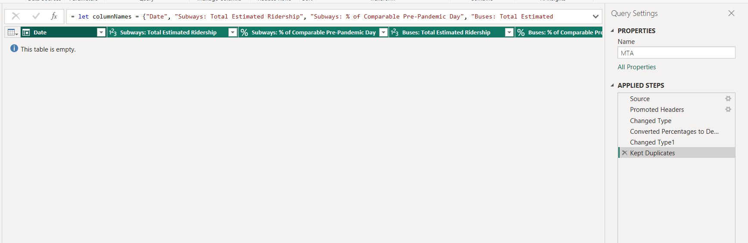
No Blanks
Rows Before blanks = Rows After Remove Blanks
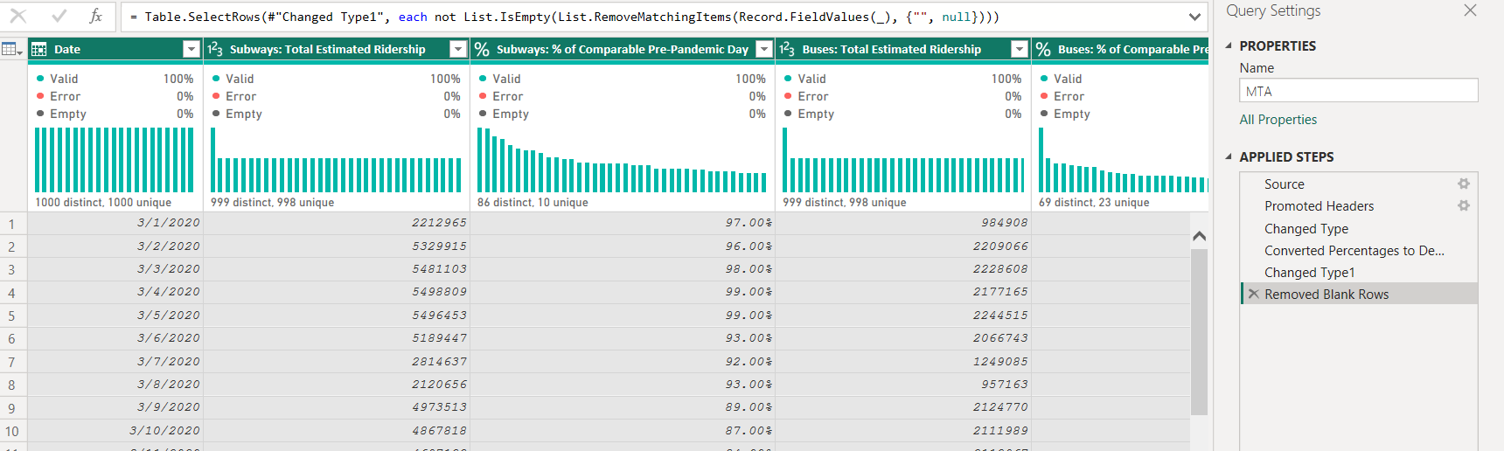
No error
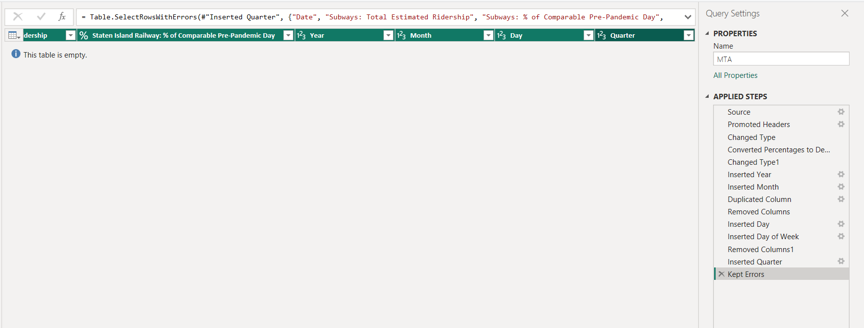

Added new columns
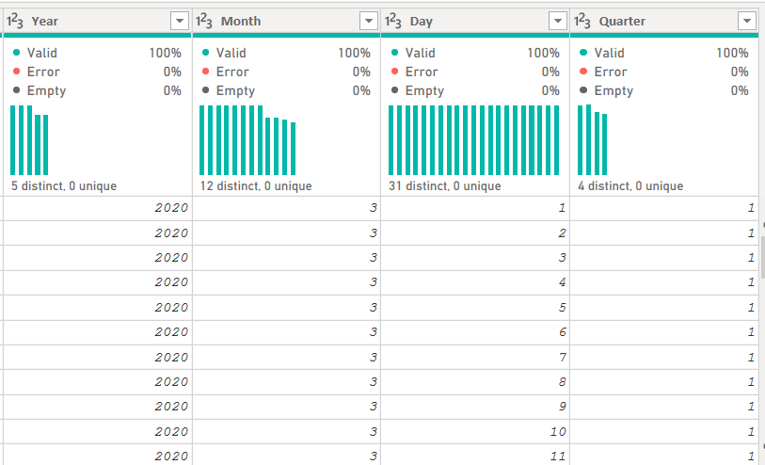
Mention if you created new columns (e.g., "Year" from "Order Date").

Final Clean Dataset (Before & After)
Before Cleaning | After Cleaning
1706 rows | 1706 rows
0 missing customer names | 0 missing names (removed them)

